Students Handout

Introduction to Web API Workshop 4

**Overview**

This workshop is designed to familiarize you with building a Web API using the Repository Pattern, incorporating AutoMapper for DTO (Data Transfer Object) mapping, and creating two controllers: UserController and JobController.

**Prerequisites**

Before starting this workshop, ensure you have a basic understanding of C# programming, ASP.NET Core, and Web API concepts.

**Workshop Content**

1. UserController

1.1. Controller Overview

Controller Name: UserController

Base Route: /api/UserController

1.2. Dependencies

IUserService: Interface for user-related operations.

IMapper: AutoMapper for mapping between DTOs and Model entities.

1.3. Endpoints

1.3.1. Register User

HTTP Method: POST

Route: /account/register

Action Method: Register(UserDto userDto)

Description: Registers a new user using DTO and AutoMapper.

1.3.2. User Login

HTTP Method: POST

Route: /account/login

Action Method: Login(LoginDto loginDto)

Description: Logs in a user and returns user information if successful.

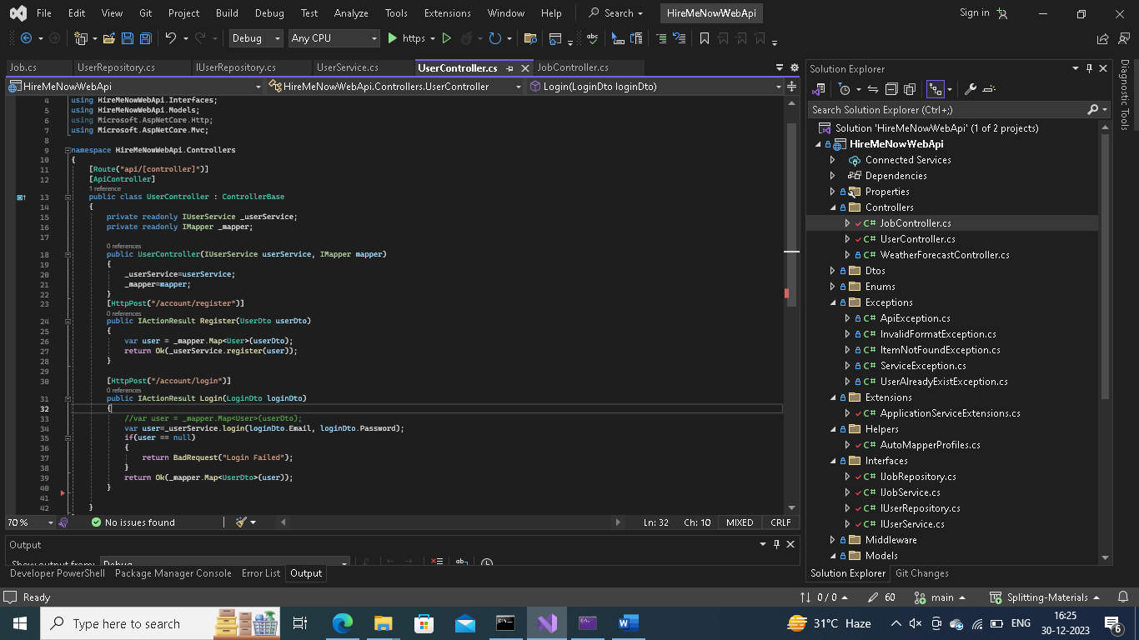

2. JobController

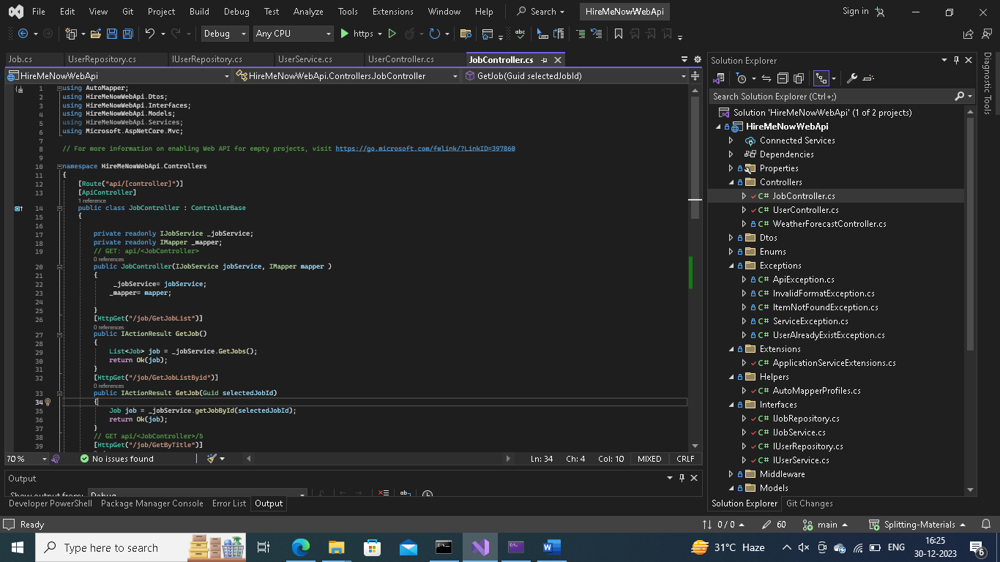

2.1. Controller Overview

Controller Name: JobController

Base Route: /api/JobController

2.2. Dependencies

IJobService: Interface for job-related operations.

IMapper: AutoMapper for mapping between DTOs and Model entities.

2.3. Endpoints

2.3.1. Get Job List

HTTP Method: GET

Route: /job/GetJobList

Action Method: GetJob()

Description: Retrieves a list of all jobs.

2.3.2. Get Job by ID

HTTP Method: GET

Route: /job/GetJobListByid

Action Method: GetJob(Guid selectedJobId)

Description: Retrieves a specific job by ID.

2.3.3. Get Jobs by Title

HTTP Method: GET

Route: /job/GetByTitle

Action Method: Get(string title)

Description: Retrieves jobs based on the provided title.

2.3.4. Post Job

HTTP Method: POST

Route: /job/PostJob

Action Method: PostJob(JobDto jobDto)

Description: Posts a new job using DTO and AutoMapper.

Conclusion

This workshop provides practical experience in building Web API controllers, implementing the Repository Pattern, and utilizing AutoMapper for seamless mapping between DTOs and Model entities. Follow the provided code samples and ask questions to deepen your understanding. Happy coding!